Department of English Language and Literature, Third year, Drama Term 2 2020

Antony and Cleopatra by William Shakespeare, 1606 ? 1608

**Lecture One: Introduction: Just to prepare for an analysis of the play**

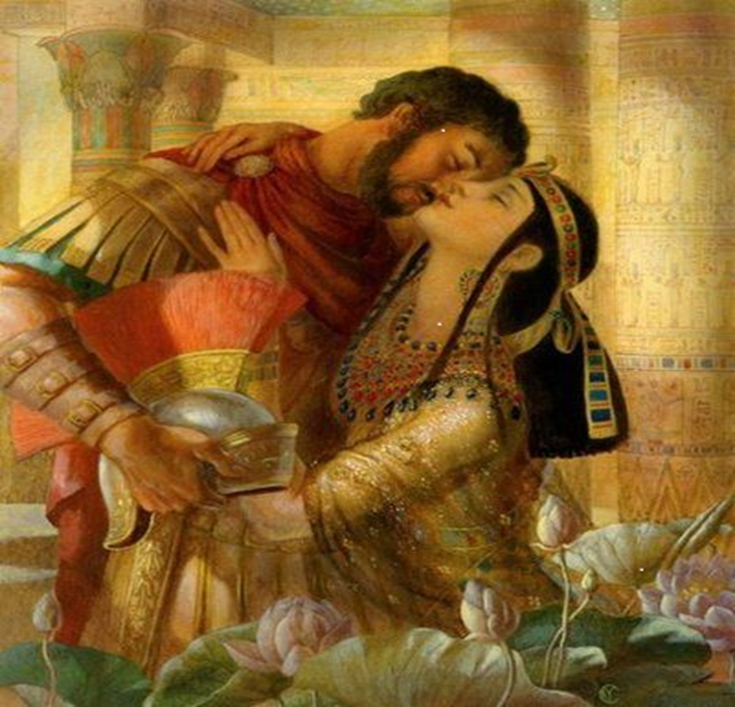

Welcome dear students to this term and to the drama course on **Shakespeare and the Restoration age**. It is sad that we cannot see each other and interact, and that I will not be blessed until further notice with your shining youthful faces where I become inspired and where I see a compass leading me into the discussion of one of the greatest plays by Shakespeare, one that I see as a masterpiece. What is happening today in the whole world is still puzzling to all of us, we are lost between believing and not believing that this Corona pandemic is a real thing, or whether there is something that is being engineered behind the scenes by the superpowers that are always seeking hegemony on the world. No matter how all this will end, there is one thing that is very clear, and that is that the world will change, and perhaps will witness the imminent end of the values of the empire, the values of the inhuman neoliberalism that has failed to solve any of the problems of this world, and, on the contrary, has created great challenges for humanity. I am saying this today because we are going to read one of the Roman plays by Shakespeare who wrote several Roman plays that celebrated the values of the empire, like ***Julius Caesar,*** ***Coriolanus, Trolius and Cressida and Antony and Cleopatra***. The Roman Empire with its expansionist war-mongering policies that are similar to the western world today, and American policy. I hope this Corona or Covid 19 craze will soon end and we will meet and enjoy our discussion of ***Antony and Cleopatra***, which is a play that opens new venues, debates and arguments that question everything from all perspectives.

The play celebrates the argumentative spirit and relativity, giving us no final answers, nor the comfort of the one and only judgement that ***Hamlet*** and ***King Lear*** have given us. It is a mature view of life provided by a mature Shakespeare later in his life and career. Dr. Wafaa Hamwi will teach you a Restoration play that I like very much, a comedy, ***The Rivals*** that belongs to a totally different age and different trend, we are not worried about chronological order of these two plays that you will study, since you know the history of English literature and you know something about Shakespeare from last year. So we are not going to spend so much time on Shakespeare's life except in relation to what matters in our discussion of the play, and where the play is located in Shakespeare's career.

**Before we start, and until I send you the second lecture about Antony and Cleopatra What do you need to know, read and prepare for your background information apart from reading the text of the play thoroughly:**

**You need to read, watch, listen and prepare:**

**I-As important background knowledge not to memorize by heart:**

**1-** A Brief reminder of Shakespeare's career to know where this play is positioned therein.

**2-**A brief overview of the period in Roman History that is in question: The life of Antony and Cleopatra after the assassination of Julius Caesar in 44 B.C with a look at Antony's career before and after, and the war for power between Antony and Octavius Caesar.

**3-**Read a detailed summary of the play, get to know the events and characters well. Keep a record of the events in a list to be in control of what really happens.

**4-**Watching some good videos of performances of the play or movies (with reservation on finding a good movie) (See internet resources below) but with a critical approach while watching. This will help your audio memory of the play, especially the theatrical performance for which I provide the link below that delivers the whole text.

5-Reading as much as your time allows on the play to broaden your knowledge.

**II-As important material to read and prepare and understand the play, and to study well:**

**1-**Reading the text of the play in full and in-depth**,** with focus on passages analyzed in lectures **(See resources below for the text)**

**2-**A broad overview/history of critical reception of the play over the years since Shakespeare wrote it, and the conflicting opinions of critics, readers, viewers and theatrical audience to the two lovers, with the view of historians before Shakespeare of the historical figures of Antony, Cleopatra and Octavius Caesar, with an awareness of the transformation of critical assessment of the play. This will be provided as we move forward in our analysis of the play.

**3-**Reading/attending the lectures for an in-depth analysis of the play.

**-Resources for the text of the play and a performance or audio file:**

**I-Text of the play:**

Check if you can find the text as New Swan Edition of Shakespeare Antony and Cleopatra:

<https://www.amazon.com/Antony-Cleopatra-Swan-Shakespeare-Advanced/dp/0582527430>

or York edition: **It is available in bookshops in Damascus**.

or Internet edition: <https://internetshakespeare.uvic.ca/doc/Ant_M/scene/3.1/index.html>, this is a good source as you can move easily between scenes.

Or this link for a good internet edition:

<https://www.opensourceshakespeare.org/views/plays/playmenu.php?WorkID=antonycleo>

**I will refer to act number, scene number and line number since we may possess a different edition**.

**For a brief summary of the play you can find many resources on the internet, but I advise you to read first a brief summary, then a very detailed one, then read the text of the play. It is essential that you read the text of the play very well and get acquainted with the characters and events so you can understand the analysis well**.

II-**Internet links for Videos of movies or performances to watch**

1. **PDF version of the play**: <https://www.folgerdigitaltexts.org/download/pdf/Ant.pdf>
2. **Audio reading of the play**:

- BBC Radio audio production 2010: <https://www.youtube.com/watch?v=m7GQ7IaHTTg>

1. **Good performance for listening to a good delivery of the text: Find below links for one performance of the play but each link will lead you to a scene or various scenes of one performance, to watch the play in full you have to watch all the links.**

1- act 1, scene one, good performance: let Roma in Tiber melt, [Shakespeare's "Antony & Cleopatra" Act I Scene I-II (Timothy Dalton and Lynn Redgrave)](https://www.youtube.com/watch?v=qHFGnT4cskU)

<https://www.youtube.com/watch?v=qHFGnT4cskU>

2-Act 1, scenes 2-5

<https://www.youtube.com/watch?v=l2EqShjbnco&pbjreload=10>

Act II, scene 1 <https://www.youtube.com/watch?v=AEgeqYsbNiw>

Act II, scene 2-5 <https://www.youtube.com/watch?v=KOpfuYGd_zU>

Act II, scene 6 <https://www.youtube.com/watch?v=0_oO8pnBAmk>

Act II, scene 7 <https://www.youtube.com/watch?v=-bakE7uGF9w>

Act III, scenes 1-7 <https://www.youtube.com/watch?v=cluBQAD1qDA>

Act III, scenes 7 -11 <https://www.youtube.com/watch?v=XN2AcprgCLc>

Act III, scenes 12-13 <https://www.youtube.com/watch?v=FaMUN8Fos8M>

Act III, scene 13 <https://www.youtube.com/watch?v=xYFEhiIOLnI>

Act IV, scene 1-8 <https://www.youtube.com/watch?v=-0Wh9uYrEp0>

Act IV, scenes 9-13 <https://www.youtube.com/watch?v=-CcHPyAHFq8>

Act IV, scene 14 <https://www.youtube.com/watch?v=nsrM__k9Wdg>

Act IV, scene 15 Antony dies in her lap, we have no friend but resolution <https://www.youtube.com/watch?v=1F1dbMUMFPc>

Act V scene 1 my desolation does begin to make a better end, min 4.54  I dreamt there was an emperor <https://www.youtube.com/watch?v=kwu-zLW-cMM>

Act V, scene 2 Caesar comes to the monument where Cleopatra is hiding

<https://www.youtube.com/watch?v=MiyKXRC9Qfc>

Act V, scene 2, last part, Cleopatra's death

<https://www.youtube.com/watch?v=l2pLBuam0BI>

**2-Movies: There are many available movies, but all should be watched with a critical eye, each movie director will make the movie for profit so it will not be a truthful presentation of the play**:

**Dear students, movies you will find on the internet are not necessarily the text the play, movie directors tend to change the language, so please watch after you read the play, so you will realize where the directors have changed the text and for what purposes, and this in itself is a good practice for your critical thinking and analysis. Remember that the videos do not represent Shakespeare's message.** I will not provide many links of videos, you can check for yourselves.

1-Trailer: <https://www.youtube.com/watch?v=qSXiQ16BOTQ>

2-Trailer: attractive movie yet not the text of the play <https://www.youtube.com/watch?v=iCCTEtoKr4w>

Antony's speech in Julius Caesar: <https://www.youtube.com/watch?v=0bi1PvXCbr8>

Try to get access to the introduction of the Swan edition that will be provided as **a handout 1** in hard copy when we meet, or I may find a way to scan it for you. I will make it available as a photocopy. The Introduction is taken from the Swan version of the text of the play, may be out of print now, but it is very useful. However, it is not all required for the exam. What is more important, if you look at the page of contents at the very beginning. You have all these sub-titles in the page of contents of this introduction:

|  |  |
| --- | --- |
| A few passages of literary criticism relating to Antony and Cleopatra | IXIX |
| Extracts from Plutarch's Life of Marcus Antonius | IXXXI |
| Bibliography | CIV |
| Antony and Cleopatra | 1 |

**Contents of the Introduction in the Swan edition/ Handout1**

|  |  |
| --- | --- |
| General Editor's foreword | Page vii |
| Introduction  Meaning and purpose in Antony and Cleopatra | ix |
| The text of Antony and Cleopatra | XXIV |
| Shakespeare's use of his source-material | Xxvl |
| The principal characters in Antony and Cleopatra | xxxv |
| The theatre of Shakespeare's day | Liii |
| Language and verse in the play | Ixii |
| Language difficulties | Ixvii |

**You need to read the following parts from the introduction: (1/ 3/5/ 7/ and a brief look at pt.) 9**

1. ***Meaning and purpose in Antony and Cleopatra***.

This is very important, and actually you have to read it well and understand it. You will come out with the most important subjects we want to discuss. It is very useful for you. You will realize that when you read it. It tells you what to expect in the play. Of course, it does not cover all what we discuss, but it really puts you on track.

1. Shakespeare's use of his source-material.

Of course, I mentioned to you that Shakespeare relied on a translation of Plutarch by Northon. So, Shakespeare took his source from Northon's translation of **Plutarch's Life of Marcus Antonius**. In this introduction, you have extensive extracts of this source.

Now, in this third sub-title which is ***Shakespeare's use of his* source material**, you have a discussion of what Shakespeare eliminated from the historical source, what he really used extensively, and what he changed. This is very important for you to know, because then you will realize Shakespeare's purpose behind using the source-material and changing it and eliminating some parts of the historical material. History is not always a reflection of reality, and the historian, artist and critic emphasize what they desire and what suits their purpose and ignore what does not suit their purpose, it is all a matter of emphasis. Sometimes the reality about history lies in what is not said, what is not emphasized and is hidden between the lines. We will discuss that further.

So, this sub-title is very important. And I will show you how to read it, because once you turn to compare the text of the play to what happened in history, then you will realize how useful it is to compare them to come out with interpretation of the play and the purpose of Shakespeare behind writing it.

1. **The principal characters in *Antony and Cleopatra***.

This is a discussion of characters. It is very useful for you. Of course, I will not bring a question in the exam that covers exactly what they say in this introduction about characters. But then imagine you have a whole discussion of each character in the play. So, this is very useful for you, but you do not need to memorize word for word for the exam. So, I advise you to read this part.

1. **A few passages of literary criticism relating to *Antony and Cleopatra***.

Well, this is something you have to read for the exam.

Again, what I am going to do here is to ask you to answer no more than six questions in the exam about who said this about the play. So, we have critical opinions about the play. So, you need to know who said this about the play. So, this requires you sometime to read and understand and classify each critic and put all the ideas in your mind.

9) **Extracts from Plutarch's life of Marcus Antonius (just reading)**

I will not ask you to read part 9 from the introduction as a compulsory matter, but when you read the source, just go across it very quickly, you will understand how Shakespeare borrowed extensively from this source. You will realize how historical the play is, how much he relied on history.

What I will do throughout lectures, as I will show you today, is that I will refer you to a passage in this section in the introduction "*extracts from Plutarch's Life*. I will refer you to a passage which really throws light on Shakespeare's use of this source-material. So, you will see today that we will go back to a passage which Shakespeare has borrowed almost extensively from the historical source, but added to it his own poetical viewpoint.

So, it is not something you need to memorize for the exam. But you have to concentrate on the passages that I will read in the introduction.

**This is then some useful material you can begin to prepare during your quarantine at home, until I send you more lectures when Dr. Wafaa Hamwi finishes her part about the Rival. You will find things easy if you prepare.**

**Until next time, with the next lecture and the beginning of our analysis of the play.**

**Take care dear students**

**Dr. Rima Al Hakim**